CS 255 Project Two: System Design Document
DriverPass System Design
Jaiden Forrest Logan

Project Overview
This system design document presents the proposed DriverPass system. The design supports online customer accounts, training package selection, driving lesson scheduling, practice tests, test progress tracking, driver notes, activity reporting, role-based access, and DMV update notifications. The document includes UML diagrams that show the system from several views, followed by the technical requirements needed to build and support the system.

UML Diagrams Included
- Use case diagram showing the main users and system functions.
- Two activity diagrams: scheduling a driving lesson and taking a practice test.
- One sequence diagram for scheduling a driving lesson.
- One class diagram showing the major system data classes and relationships.

UML Use Case Diagram
The use case diagram shows the main people and outside systems that interact with DriverPass. It includes customers, the secretary, the owner, the IT officer, drivers/instructors, and the DMV system. The main functions include account access, lesson scheduling, practice test progress, package management, activity reporting, driver notes, and DMV updates.

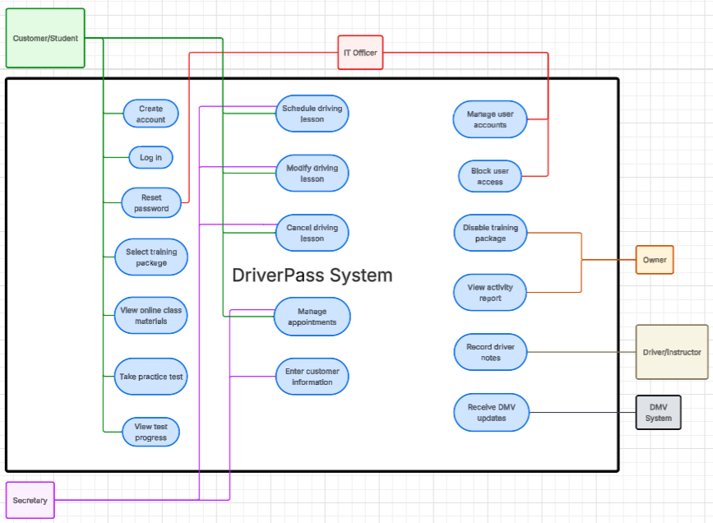
Figure 1. DriverPass use case diagram

UML Activity Diagram 1: Schedule Driving Lesson
This activity diagram breaks down the schedule driving lesson process. It shows how a customer or secretary logs in, selects a package, enters lesson details, checks driver and car availability, and creates a reservation if the requested time is available.
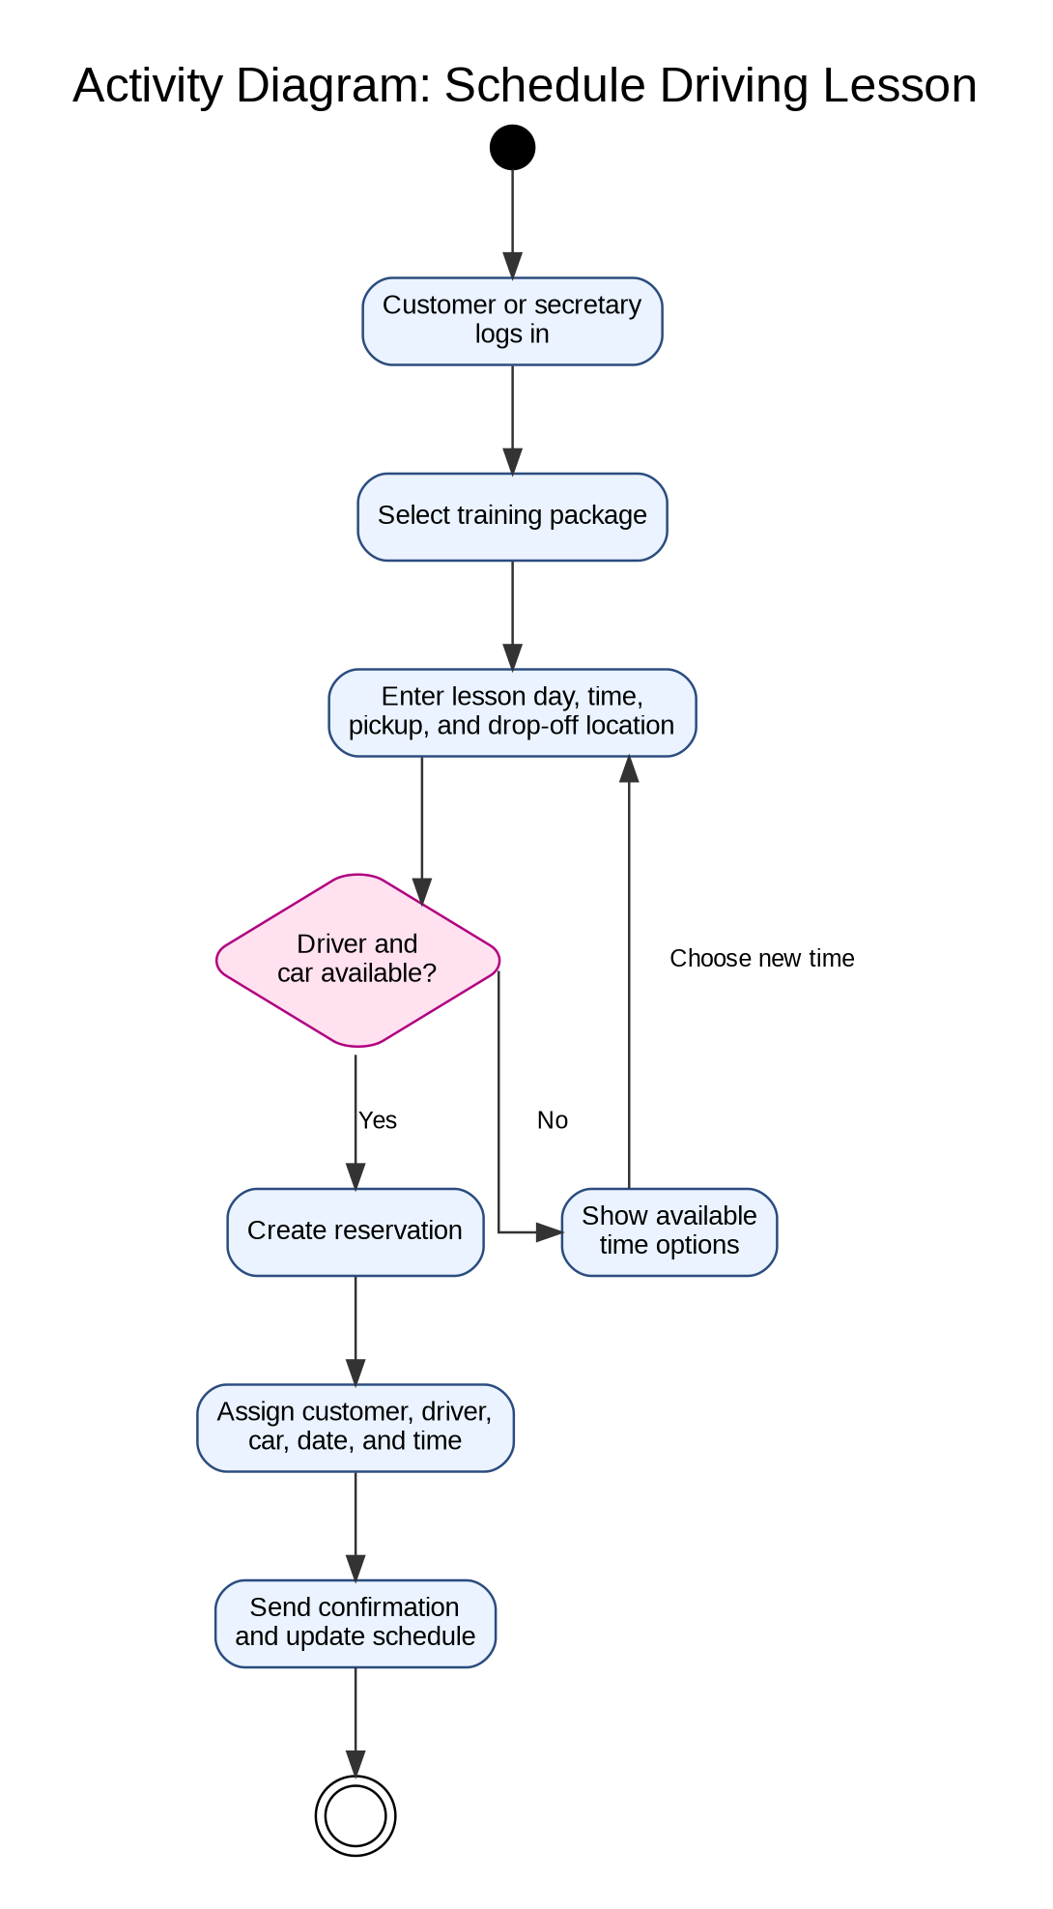
Figure 2. Activity diagram for scheduling a driving lesson

UML Activity Diagram 2: Take Practice Test
This activity diagram shows how a student takes a practice test and views progress. It includes checking whether the student has online class access, choosing a practice test, submitting answers, calculating the score and time taken, and updating the test progress status.
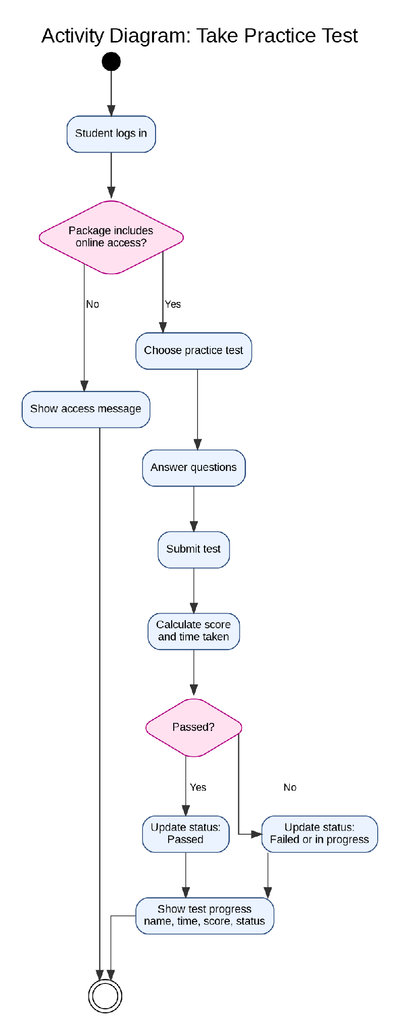
Figure 3. Activity diagram for taking a practice test

UML Sequence Diagram
The sequence diagram focuses on the schedule driving lesson use case. It shows the order of communication between the customer or secretary, the DriverPass web app, the reservation service, the schedule data, and the notification system.
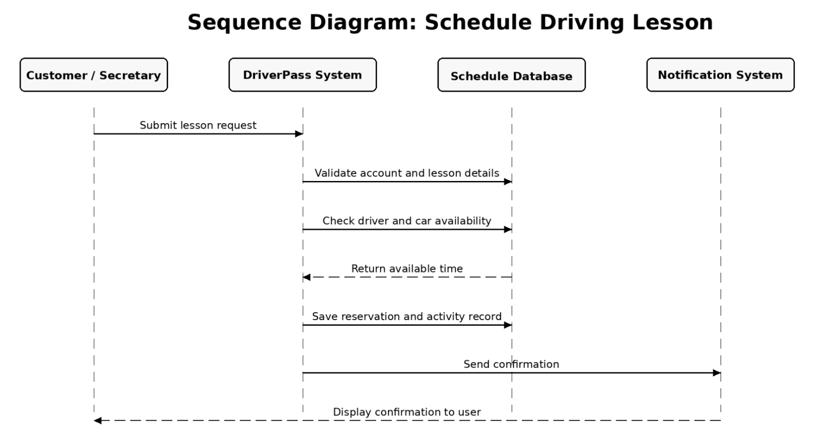
Figure 4. Sequence diagram for scheduling a driving lesson

UML Class Diagram
The class diagram identifies the major data classes needed for DriverPass. These include users, customers, employees, training packages, reservations, drivers, cars, practice tests, test progress, driver notes, and activity reports.
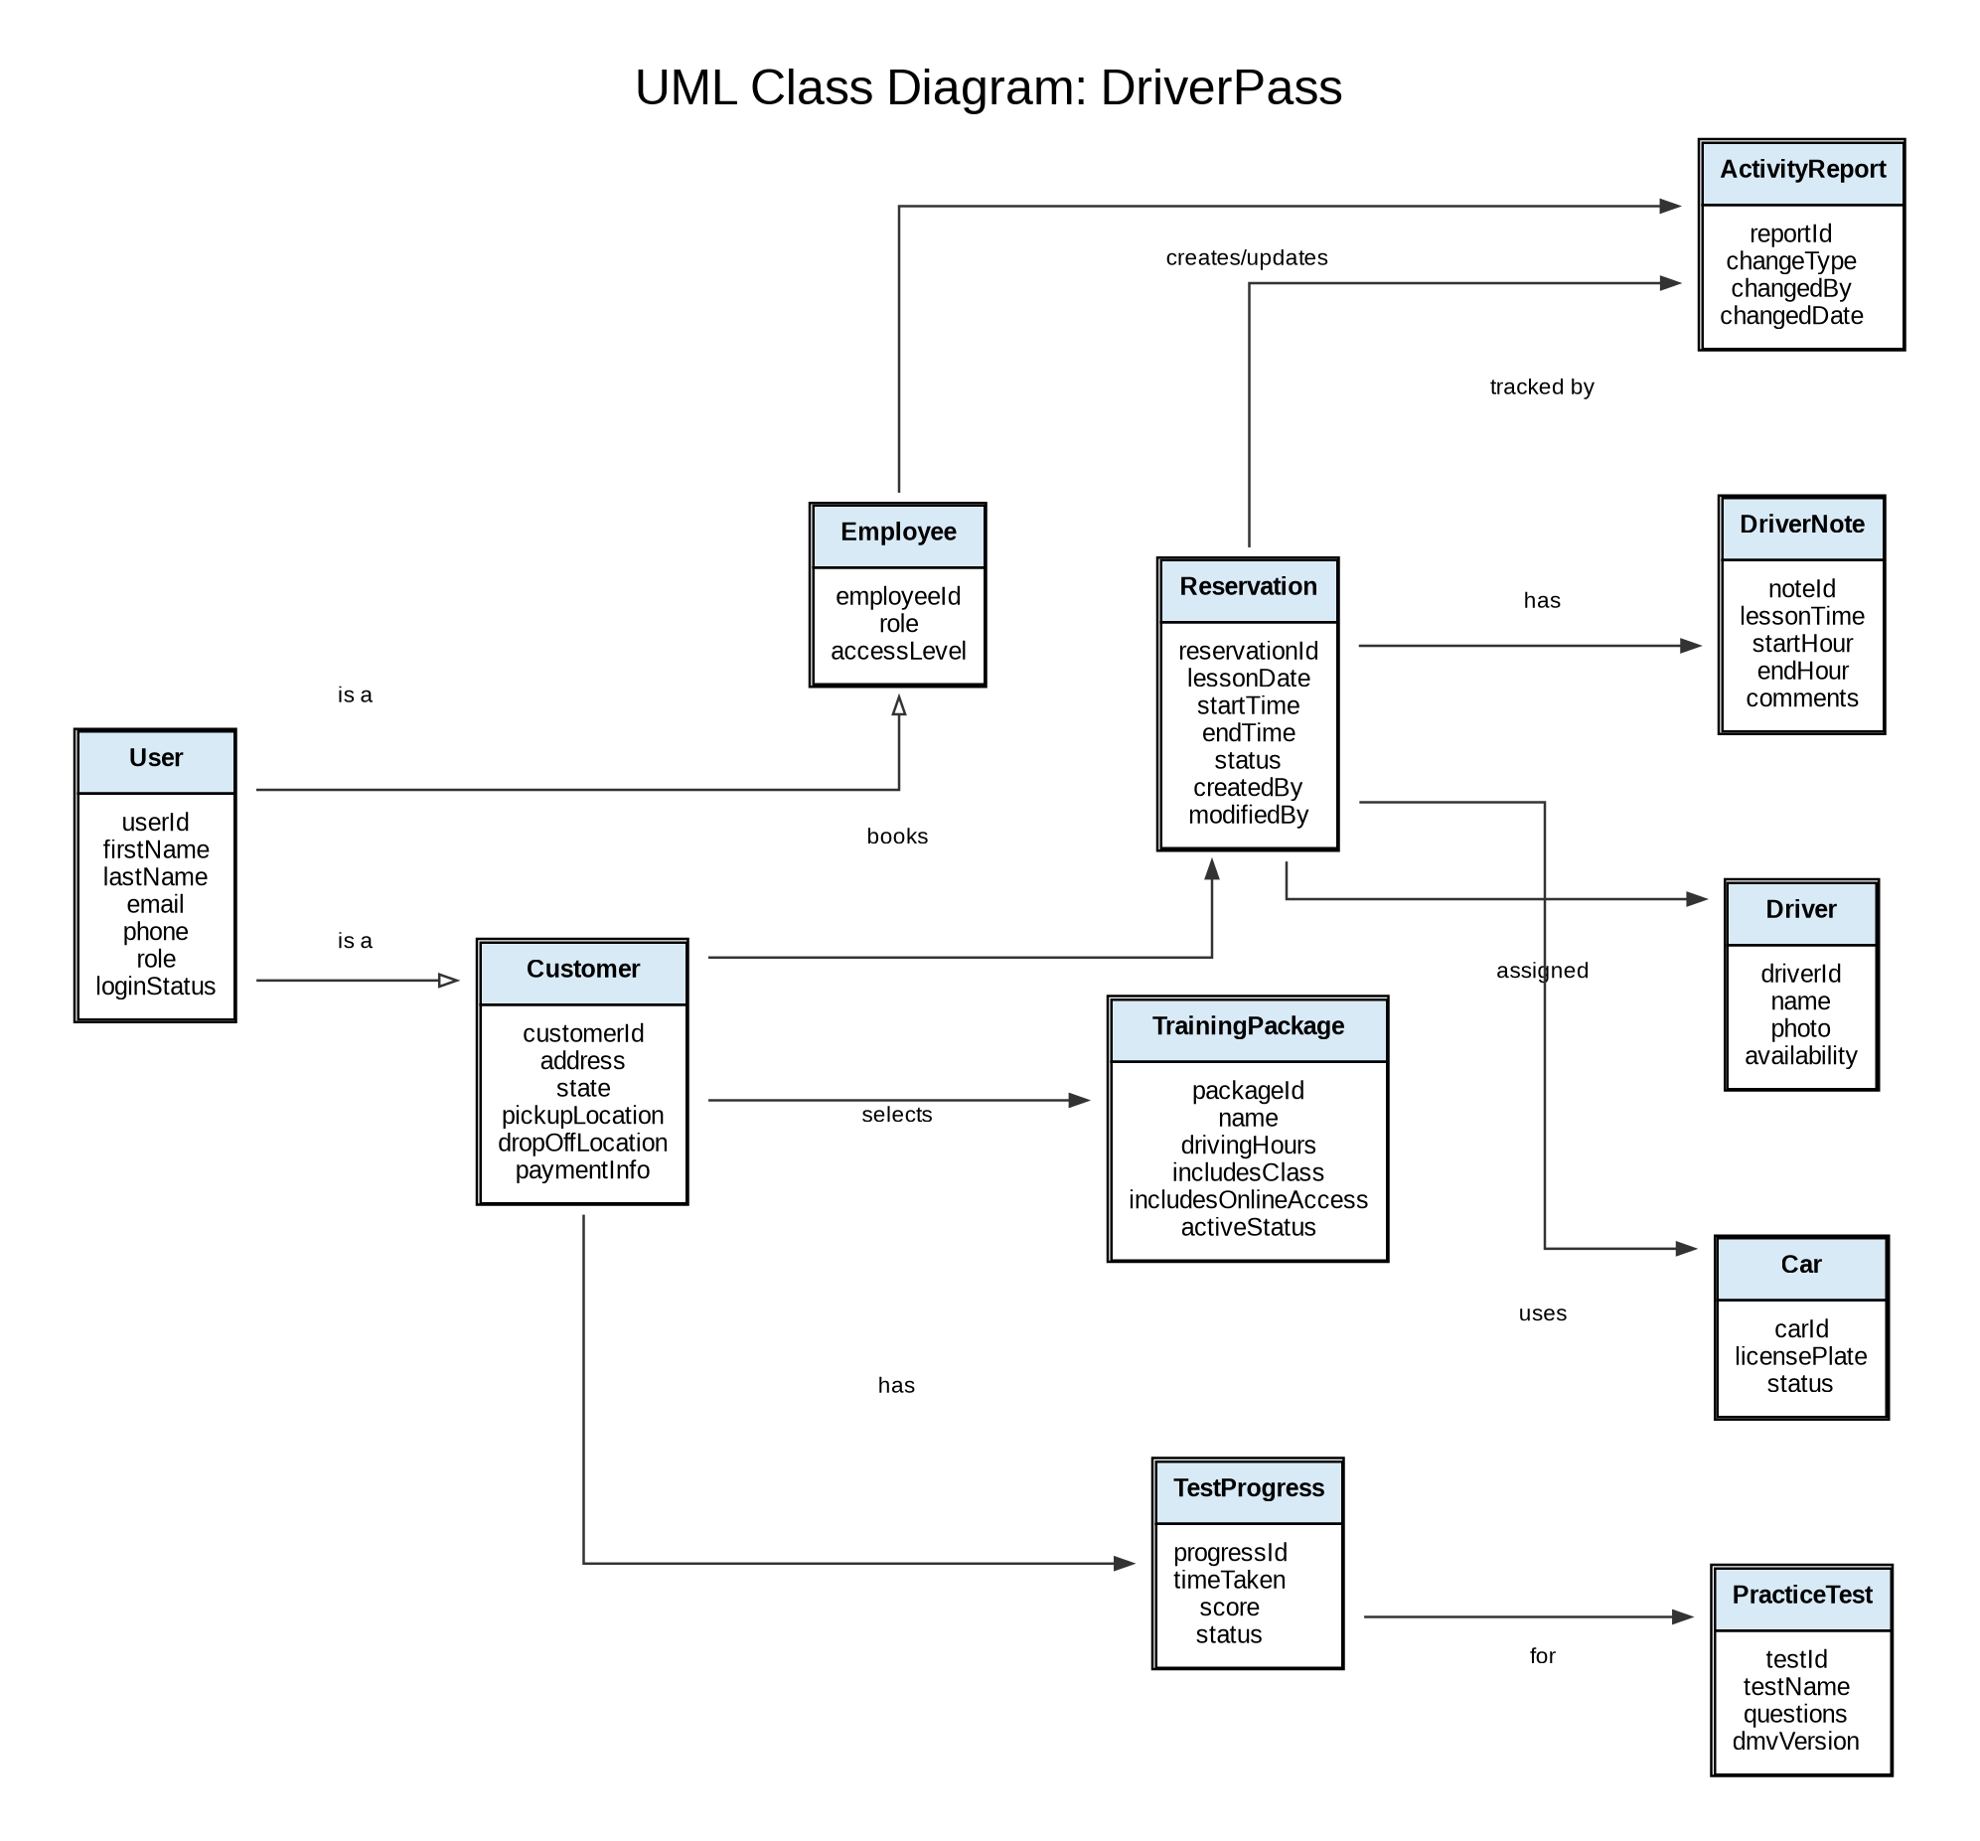
Figure 5. DriverPass class diagram

Technical Requirements
The DriverPass system should be web-based and cloud-hosted so customers and employees can access it from a computer, tablet, or mobile device. The system should support online access for customers while also allowing Liam to download reports for offline review in tools such as Excel.
The system will need a secure web server, application server, and relational database to store customer records, reservations, package information, driver/car assignments, test progress, driver notes, payment records, and activity logs. The database should be backed up regularly by the cloud provider.
The software should include role-based access. Customers should only access their own account, practice tests, and reservations. The secretary should manage customer information and appointments. The IT officer should manage user accounts, reset passwords, and block access when needed. The owner should be able to view activity reports and manage training packages.
Security requirements include secure logins, password reset support, encrypted communication between the browser and server, protected payment information, and an audit trail that records who creates, modifies, or cancels reservations. The system should also notify DriverPass when DMV rules, policies, or sample questions are updated.
The interface should include forms for customer information, package selection, scheduling lessons, viewing online test progress, and reviewing driver notes. It should also support driver and student photos, contact information, and special needs where applicable. The system should be flexible enough for DriverPass to disable packages without requiring new code changes.

